Appendix to the online version

Figure 1. Twitter posts showing the vandalization of the mural. Retrieved from a Twitter public account, @lamai16291463, January 23, 2021.
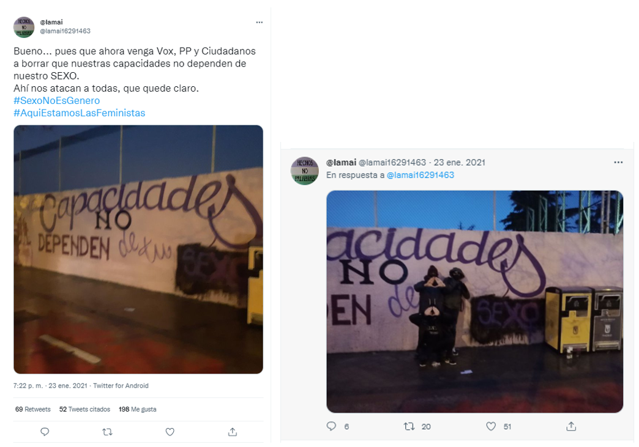

Figure 2. The transfeminist mural. Own photograph, March 8, 2021.
